2020 National Housing Quality Awards

The Measurement of Excellence

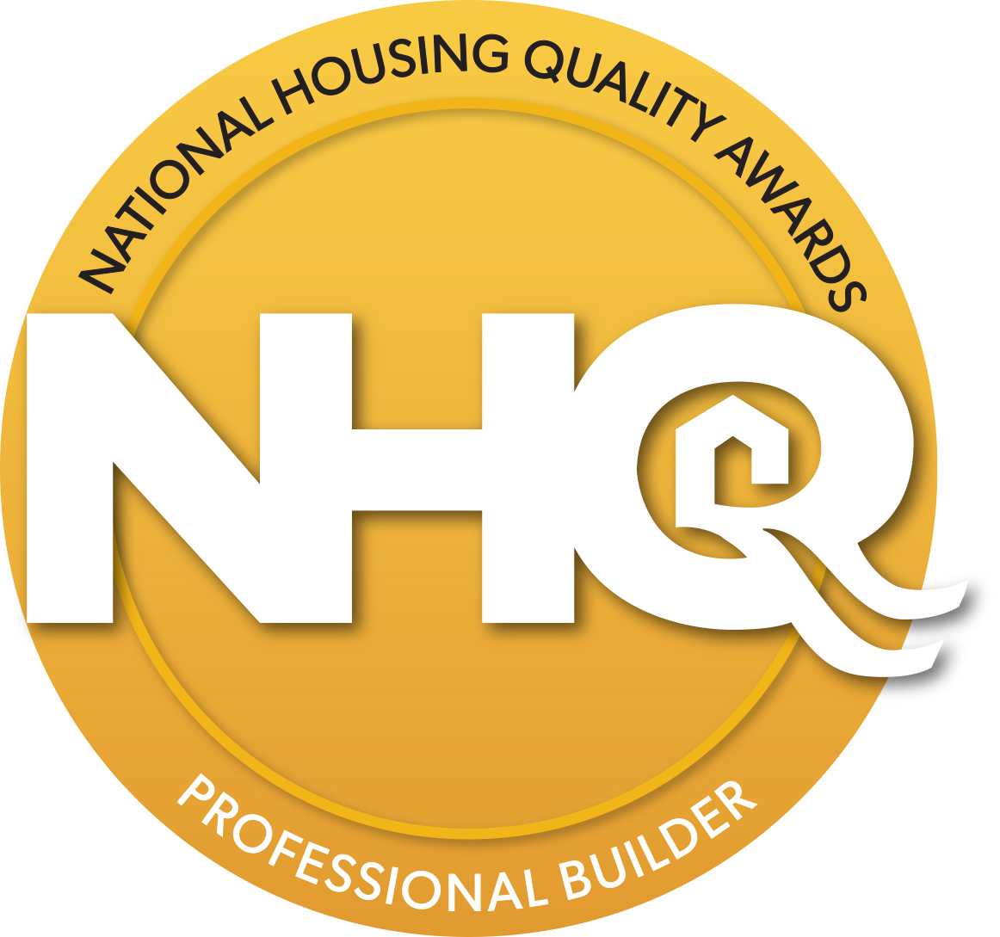

Part II

The Application Process

Table of Content

III. THE GOLD STANDARD
IV. PREVIOUS RECIPIENTS
VI. Are you ready for the NHQA challenge?

VII. Four Award levels
- THE NHQ AWARDS APPLICATION PROCESS
- The NHQ Award Application
X. AWARD CATEGORIES
IX. LEADERSHIP
X. STRATEGIC PLANNING
XI. PERFORMANCE MANAGEMENT
XI. CUSTOMER SATISFACTION
XII. HUMAN RESOURCES
XII. CONSTRUCTION QUALITY
XIII. TRADE RELATIONSHIPS
XIII. BUSINESS RESULTS
XIV. CONTACT INFORMATION PAGE

The Gold Standard

The NHQ Award is modeled after the Malcolm Baldrige National Quality Award and represents the housing industry’s highest recognition for achievements in quality management.

This program is more than just an award, it is the template of foundational elements critical to business success. Builders use the NHQ Award process to improve their business in many facets which result in increased customer, employee and partner satisfaction, along with operational effectiveness and an improved bottom line. Each applicant receives a detailed written feedback report, which can be used as a guide for future improvement. The NHQ Award process provides objective benchmarking for the home building industry and is applicable to both small and large volume homebuilders.

The NHQ awards are open to all North American residential home building companies. Throughout the years, there have been 52 Gold Level recipients, 41 Silver recipients, and 10 Bronze recipients. As a testament to the value of taking the NHQ awards challenge, Of the 103 previous award recipients, 90% are still in business today.

Recipients of the
National Housing Quality Award

 | Gold | True Homes
2019 Award Recipients | Silver | Garman Builders, Inc
 | Silver | JayMarc Homes, LLC
 | Bronze | Thrive Home Builders

2018  Tim O'Brien Homes - Gold  Pacific Lifestyle Homes - Gold  Goodall Homes - Silver  2017  Classica Homes - Gold  Tim O'Brien Homes - Silver  CBH Homes - Bronze  2016  Veridian Homes – Gold  Goodall Homes – Silver  Maracay Homes – Silver  Tim O’Brien Homes – Silver  Garman Builders – Bronze  2015  DSLD Homes – Gold  EYA – Gold  French Brothers – Silver  2014  French Brothers – Bronze  2013  Charter Homes – Gold  Wayne Homes -- Silver  DSLD Homes – Silver  Vintage Homes – Bronze | 2012  Wathen-Castanos –Silver  Charter Homes – Silver  Schumacher Homes – Bronze  Goodall Homes – Bronze  2011  Haseko - Bronze  Wathen-Castanos – Bronze  Charter Homes - Bronze  2010  Simonini Builders — Gold  Wayne Homes — Silver  2009  T.W. Lewis — Gold  K. Hovnanian Virginia Division — Silver  K. Hovnanian Northern California  - Honorable Mention  2008  Fireside Hearth & Home (National) — Silver  Mungo Homes — Silver  Barratt American (National) — Silver  Pringle Development — Silver  Mercedes Homes (National) — Silver  2007  Estes Builders — Gold  Floor Art — Silver  Schuck and Sons — Silver  Keystone Custom Homes —Honorable Mention  Atlantic Builders — Honorable Mention

2006  Shea Homes San Diego — Gold  Veridian Homes — Gold  Ideal Homes — Gold  CP Morgan — Silver  Pringle Development Inc. — Silver  KB Home Las Vegas — Silver  2005  Grayson Homes — Gold  Pulte Homes (National) — Gold  Ideal Homes — Silver  Estes Builders, LLC — Silver  Veridian Homes — Silver  Pringle Development, Inc. —  Honorable Mention  2004  Grayson Homes — Silver  Boardwalk Builders — Silver  Schuck and Sons — Silver  2003  History Maker Homes — Gold  Pulte Homes Minnesota — Silver  Fairmont Homes — Silver  Neumann Homes — Silver  ALL-tech — Silver  Tappe Construction — Silver  Grayson Homes — Honorable Mention  2002  Don Simon Homes — Gold  Shea Homes Colorado — Gold  2001  Palm Harbor Homes,  Florida Division — Gold  Simonini Builders — Gold  Don Simon Homes — Silver  Winans Construction, Inc. — Gold  Stebnitz Builders — Silver  Cupertino Kitchens — Honorable Mention  1999/2000  Shea Homes Arizona — Gold  Sunrise Colony Companies — Silver  The Green Companies — Silver  Traditional Concepts, Inc. — Gold  Legacy Custom Builders, Inc. — Gold  Deck America, Inc. — Gold  Lasley Construction, Inc. — Silver  Bell’s Remodeling — Honorable Mention | 1998  Neumann Homes — Gold  The Estridge Co. — Gold  T.W. Lewis — Silver  Fairway Construction — Gold  Remodeling Designs, Inc. — Gold  Kendale, Inc. — Gold  1997  K. Hovnanian Enterprises — Gold  Kennedy Community  Development, LP — Gold  U.S. Home Corp. Houston — Silver  Coventry Construction, Inc. — Gold  Eren Design & Construction — Gold  Asdal Builders, LLC — Silver  Fairway Construction — Silver  Mitchell, Best & Goldsborough  Inc. — Silver  1996  Mercedes Homes, Inc. — Gold  Rayco — Gold  Shea Homes San Diego — Gold  Triple Crown Corp. — Gold  Neil Kelly Co. — Large Remodeler  J.J. Swartz Co. — Large Remodeler  Criner Construction — Small Remodeler  Kleinco Construction Services  — Large Remodeler  Crown Construction — Honorable Mention  1995  Doyle Wilson Homebuilder, Inc. — Gold  John Wieland Homes, Inc. — Gold  Oakwood Homes — Gold  Pulte Homes Illinois — Gold  Toll Brothers — Gold  1994  The Drees Co. — Gold  Kennedy Home Builders – Gold  Village Builders – Gold  1993  Cannon Development -Gold  Carmichael & Dames Builders – Gold  Fieldstone Communities, Inc. – Gold  Town & Country Homes – Gold  David Weekley Homes - Gold  Winchester Homes --Gold

Let the NHQA program help your organization be the best it can be?

The NHQ Award process can help you prepare for changes occurring in today’s dynamic housing market. Studying the award criteria will open your mind to new possibilities for improvement and propel your company to new heights.

For 26 years, the NHQ Criteria for Performance Excellence have been important tools for hundreds of homebuilders. These criteria can help you:
- Align resources
- Improve communication
- Increase productivity
- Boost effectiveness
- Achieve strategic goals
- Understand and change your organization’s culture

You may enter your entire company or only a division of it. Multiple winners in each category and at each level may be selected. Previous Gold Award winners are eligible to apply again in the third year following their gold award.

Reviews are thorough and fair

A panel of highly qualified experts, made up of previous winners and quality management experts, evaluates all the applications and selects finalists who demonstrate high levels of quality achievement. Examiners might request additional information during the selection process, including lists of customers for an independent satisfaction survey, company references or other information related to the evaluation criteria. Every 3 to 4 years we do a thorough review of the criteria and questions we use to evaluate the applicants to ensure we are always improving the Award program.

Finally, NHQ Award examiners visit the finalists to review and validate their application.

If you win an NHQ Award, we will encourage you to publicize and advertise your winning status.
It will have been hard-earned and well-deserved; it will cement your reputation with customers and peers as a top-quality builder and it will distinguish you from your competitors, giving you the business edge you desire as it raises your company’s reputation as an industry leader.

If you’re commited to quality,
please let the
NHQ Awards help.

Winners are recognized in four categories

GOLD – Awarded to companies that have attained a national benchmark level within each area of evaluation. -- Gold Award winners have mature, fully integrated quality management principles and consistently demonstrate high-level, sustained financial results.

SILVER – Awarded to companies that are industry leaders in most evaluation areas -- Silver Award winners have many refined business practices — including key measures for continual improvement — and they exhibit good financial results.

BRONZE – Awarded to companies that have a sound systematic approach that is responsive to the Award benchmarks in many areas – Bronze Award winners employ fact based improvement processes with no major gaps and above average performance in most area – They are close to the Silver Award mark.

Honorable Mention – In special situations companies are recognized that demonstrate an understanding of quality management principles and show a sound, fact-based improvement process. Key measures are in place and good financial results are achieved in most areas.

Preparing the NHQ Award application is an important step in every applicant’s quality journey.

When applying for the NHQ Award you ONLY compete against the Award criteria.

Multiple Gold, Silver and Bronze can be awarded each year.

The NHQ Awards Application Process

The application has two parts:

- The first part is the application commitment form
- The second part is the application itself following the directions below

APPLICATION SUBMISSION REQUIREMENTS
Please complete your application in an electronic document formatted as follows:

- The entry must be presented on 8.5 in. x 11 in. pages

- The document must use 12 pt. Times New Roman font

3. The Award entry application must be a maximum of 18 pages plus one overview page

4. Do not send or reference “attachments” or other documents. The judges only receive the overview page and the 18-page application

- The application commitment(Part I) form and a check should be sent by March 15, 2019 to:

Serge@Potomack.net and to ddersin@sgcmail.com

- An electronic copy of the application (Part II) should go to Serge Ogranovitch at Serge@potomack.net

- A printed copy of the application, should go to:

Denise Dersin at Professional Builder Magazine
3030 W. Salt Creek Lane, suite 201, Arlington Heights, IL 60005-5025

Entries due by April 19, 2019

The NHQ Award Application

Your very first step is to provide a brief profile of your company. This should include:

- The types of products and services you provide

- The market and geographic area you serve

- Your competitive situation

- Business direction

- Any other relevant information you want to include

If you are submitting an application for a division of a larger corporation, please describe the operating relationship to the parent company.

Next proceed with the eight sections of the Award. The sections are described in the following pages. To make it easier to follow we are providing some general information on what the judges are looking for.

Those are to be used as a guide only and are not meant to be an outline of what the content of your application should be.

NHQ Award Categories

Below is an outline of the 8 categories that we ask you to address in your application with the important key points.

Leadership- How your senior leaders personal actions guide and sustain your organization? How your organization fulfills its Legal, Ethical and Societal responsibilities and supports it’s Community?

At a minimum your answer should reflect these discussion points:
1. The company mission that gives purpose to your organization
2. The company values that guide corporate decisions and behaviors
3. Your vision of what your company can become
4. How senior leaders instill and reinforce the mission, values and vision within the
company as role models and by empowering others
5. How employee feedback on company priorities is elicited and utilized
6. How company results are communicated to employees
7. How the company demonstrates public responsibility and good citizenship

Strategic planning - How do you create and carry out a strategic plan to achieve a future vision, enhance your competitive position and improve overall performance?

At a minimum your answer should reflect these discussion points:

1. The key strategic challenges your company faces in the next 1-5 years
2. How these challenges are identified and analyzed
3. How you use demographic data and market intelligence in strategic planning
4. How the strategic plan is tied to your mission, vision, and values
5. How the plan leverages your company’s unique skills, knowledge and experience
6. How the plan compensates for lack of skills, knowledge, experience and/or resources
7. How your company’s strategic plan is deployed
8. How your company’s strategic plan is activated
9. The operational impact of the strategic plan
10. How your company acquires or develops the necessary skills for plan implementation
11. How you utilize performance metrics and feedback channels
12. How you report and communicate progress
13. How leaders use feedback to adjust the plan
14. How do you acquire new customers
15. How do you maintain your customer pool
16. What tools and data do you use to generate and maintain leads

NHQ Award Categories

Process Management - How are your company’s business processes developed, managed, measured and improved to achieve performance excellence?

At a minimum your answer should reflect these discussion points:
- How do you approach essential business processes
- How do you involve various departments
- How do you establish expectations
- How do you document implementation of new processes
- How do you use KPIs (Key Performance Indicators)
- How do you track and communicate KPIs
- What tools do you use for process improvement
- How you improve your key processes
- How are trade partners involved in your management process
- How do you maintain accuracy in sales materials
- Describe your sales process
- What is your performance evaluation process

Customer Satisfaction - How do you define, design, measure and manage the delivery of products and services that lead a high level of customer satisfaction

At a minimum your answer should reflect these discussion points:
- How you identify market segments and key customer groups
- Describe the methods you use to define and develop a customer centric culture.
- How you determine levels of focus on select segments or groups
- How you select customer-desired product features and services
- How you develop customer relationships
- Describe how your key customer satisfaction processes are measured and managed
- Describe how your key customer satisfaction processes are improved
- Describe how your key customer centric processes are implemented
- How your company obtains and utilizes customer satisfaction feedback to improve performance
10. Sales process impact on Customer Satisfaction

Note.

If a site visit is conducted and the applicant does not use a third party for customer satisfaction feedback, the NHQA may conduct an evaluation of customers for the past 12 months.

NHQ Award Categories

Human Resources - How Human Resource practices contribute to the growth of the organization by looking at employee selection and developmewnt as well as staff performance management, well being, motivation, satisfaction and compensation?

At a minimum your answer should reflect these discussion points:
1. How your organization maintains a work environment that contributes to the well-being, satisfaction and motivation of staff
2. Ways your company maintains or enhances employee morale
3. A description of your company culture
4. Company benefits offered to employees
5. Your organization’s career development (education & training programs)
6. How programs support superior work performance and help achieve the company’s overall objectives
7. The role, if any, of an employee handbook
8. How employees document and access policies, processes and procedures
9. Employee retention techniques
10. How you ensure organizational alignment
11. Discuss your employee recruitment strategy
12. Discuss your new hire and internal applicant interview process
13. How you administer employee evaluations
- Compensation, recognition and incentive programs
- Discuss organizational succession plans
- Describe your safety training program
- How are safety results shared with employees and trades

Construction Quality – What methods does your company use to drive quality in the home construction process and ensure HIGH PERFORMING, trouble-free products and services?

At a minimum your answer should reflect these discussion points:
- Describe your quality Standards
- Education and reinforcement of quality standards to employees and trades
- Describe your warranty process
- Your quality review process for new plans, production homes and new communities
- Your customers’ involvement in the quality review process
- Your customers’ post-closing experience
- Any quality recognition programs
- Any continuing improvement processes
- Quality defect prevention and correction processes

NHQ Award Categories

Trade Relationship - The company has a valuable base of loyal partners that needs to be considered as part of the future success of the organization. They need to be informed and included in the planning and performance improvement efforts of the company.

At a minimum your answer should reflect these discussion points:
1. Your framework for establishing mutually beneficial relationships
2. Your trade partner selection process
3. Communication channels utilized
4. Your process for developing trades to meet organization goals
5. Your process for assessing trades’ performance and communicating compliance
6. Pro-active problem avoidance through trade involvement
7. Encouragement of trade contributions to the greater good of your organization
8. Integration of trades in building a better company
9. Your trade partner feedback system

Business Results - HIGH PERFORMANCE BUSINESS PRACTICES ARE EFFECTIVE ONLY IF THEY RESULT IN BUSINESS BENEFITS AS DEFINED BY TANGIBLE FINANCIAL, OPERATIONAL, CUSTOMER SATISFACTION AND PRODUCT/SERVICE QUALITY MEASURES.

For this section we ask that you provide 3 years of data for each of the main questions.

Data can be provided in graph, table or bullet point format.

At a minimum your answer should reflect these discussion points:
1. Customer Satisfaction Results
2. Operational Metrics and Results
3. Human Resources
4. Market Results
5. Trade Relations Results
6. Constructed Quality and Warranty Results
7. Financial Results

The NHQA process

The following is the process and schedule for the 2020 NHQ Award

WHAT | WHEN
Application Part I and Part II available | December 2018
Handouts draft | January 11, 2019
IBS - meet with potential applicants in Las Vegas | February 19 - 21
Application Part I is due | March 15
Application Part II is due | April 19
Review of Application | April 20 - 24
Meeting of Judges for the 2020 NHQA and assignment of desktop review teams - Applications to Judges | April 25 -26
Teams complete review of applications | May 20
Judges' conference call to review application and recommendations for site visits | May 21
Notification to applicants of site visits (or not) | May 22
Site visits by teams of 3 judges plus NHQA director, site visit time may be expanded 1 week past the July 4th holiday, if needed | June 3 - 28
Judges conference call to review evaluations and award level recommendations, based on review of all judges involved | July 15
Call to applicants' contact to share the judges' decisions | July 16 & 17
Feedback reports due to applicants | August 15 -22
Award are handed out at the Housing Giants Leadership Conference at the ANZA Scottsdale Resort & Spa | October 16 & 17

For further information or questions about the National Housing quality Award (NHQA)

Please contact: Serge Ogranovitch at Serge@Potomack.net or

703-980-6565

You can also join us on:

Facebook https//www.facebook.com/pages/National-Housing-Quality-Award

LinkedIn https://www.linkedin.com/groups/Nationl-Housing-Quality-Award-1469587/about

